### 

1.mysql> select ename,sal*1.20 AS SALARY from emp;

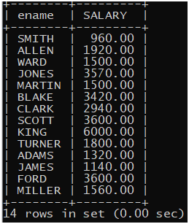

2.mysql> select concat(ename," ",job) as "NAME AND JOB" from emp;

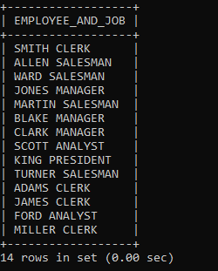

5.mysql> select ename from emp where job="CLERK";

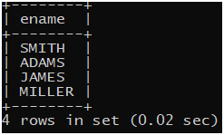

6.mysql> update emp set job="salesperson" where job = "salesman";



8.mysql> select ename,date_add(hiredate, interval 1 year) as "COMPLETION OF PROBATION" from emp order by hiredate;

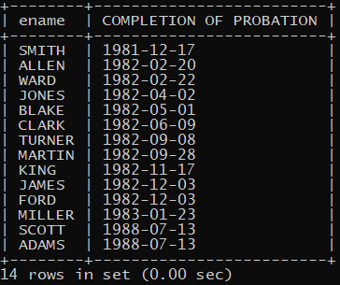

9.mysql> SELECT ename,IF(sal>1500,sal,IF(sal=1500,"ON TARGET","BELOW 1500")) as "SALARY" from emp;

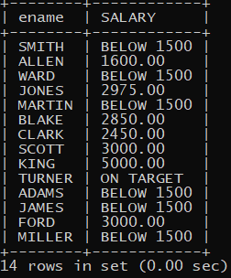

10.mysql> select dayname(sysdate());

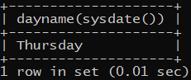

11.mysql> SELECT ENAME , DATEDIFF(CURDATE(), hiredate) AS "Days in Service" from emp;



14. mysql> select min(salary) from emp;

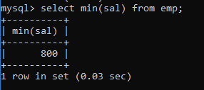

15. mysql> select min(sal),max(sal),average(sal) from emp;

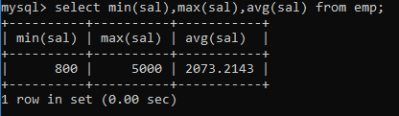

16. mysql> select job,min(sal),max(sal) from emp group by job;

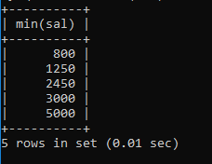

17. mysql> select count(mgr) from emp;

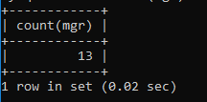

19. mysql> select max(sal)-min(sal) from emp;

